Class Final Review

* Anything involving Raytracing is fair game. Should be experts
  + View dependent
  + Computationally expensive
  + Good for retraction and reflection effects
    - Nvidia has created technology to speed up and do things well.
* Z-buffer graphics pipeline
  + Modeling transformation -> Viewing Transformation -> Projection transformation -> Perspective Division -> Viewpoint transformation -> Rasterization
* Illumination and Shading
  + Memorize all equations involved in the Phong model: ambient specular and diffuse
    - Ka \* O
      * Ambient: Ambient Coefficient \* Base Color
    - Kd \* max(N\*L, 0) \* O\*Lc
      * Diffuse: Diffuse Coefficient \* (normal \* light direction) \* light color
    - Rs \* pow(max(R\*L,0),n) \* Lc
      * Specular: Specular Coefficient \* (reflected vector \* eye direction) ^ smoothness \* light color
  + What are inputs to those equations, what do they mean? For example, what does the exponent “n” refer to.
    - N refers to smoothness number, higher it gets, shinier it is.
      * Red light on white object is red
      * Red on green object is black.
      * The color of the highlight is the color of the light source.
      * Color of a mirror is (slightly green ?)
    - Memorize equations related to local illumination and shading.
  + How do we calculate the reflectance vector?
    - R = V – 2N(N\*V)
      * Image vector - 2 \* (normal \* image vector ) \* normal vector
  + How do specular and diffuse shadings change as the light location or viewpoint change.
    - Diffuse: reflected intensity depends only on the direction of the light source
    - Specular: appearance changes as the viewpoint moves.
  + Phong illumination model
    - Not accurate
    - Good for specular effects
  + Flat shading
    - Fastest method
    - Lower quality results
    - Each polygon has a uniform color, great for low quality
  + Gouraud shading
    - Color vertices and interpolate colors at pixels
    - Colors at vertices are interpolated to find colors over a polygon
  + Phong shading
    - Color pixels by interpolating normal at each pixel.
* Normal Vectors
  + Be able to calculate the normal vector of
    - A plane
      * Find cross product of two vectors on the plane
    - An arbitrary implicit function
      * Using Gradient, f(x,y,z) = 0; if ask for normal of geometric, take gradient, partial derivative, vector who’s component is partial derivative of x to x, y, and z. that vector is guaranteed to be normal to the plane at any location on the surface
    - A sphere
      * The vector to the point you want, every vector that leaves origin of sphere is normal
    - A parametric surface
      * 3 functions of 2 parameters, partial derivative of each of the function in terms of u, 3 partial derivatives give tangent vector in u direction, do it again for v, and get new vector. Need a vector that’s orthogonal to those two, which gives you a normal.
* Affine Transformations
  + May not preserve angles
  + May not preserve edge lengths
  + Always preserve parallel lines
  + Always preserve “in-betweenness”
  + Always preserve ratios along a line.
    - Where midpoint or 1/3 are in a line.
* Transformations
  + How do we transform a line with a matrix?
    - Transform 2 points and specify a new line through the two points, nice property of affine transformations.
  + How do we transform a plane with a matrix?
    - Transpose(invert(M)) \* N
  + What are the series of transformations that reflect a point across a line?
    - Rotate the line to an axis, do a flip, and rotate the line back.
  + What are transformations that will convert one-line segment to a different line segment?
    - Rotate line to one, scale, rotate out to meet other. Be able to scale in terms of the origin.
  + Given two coordinate systems, find the matrix that transforms points from one to the other.
    - 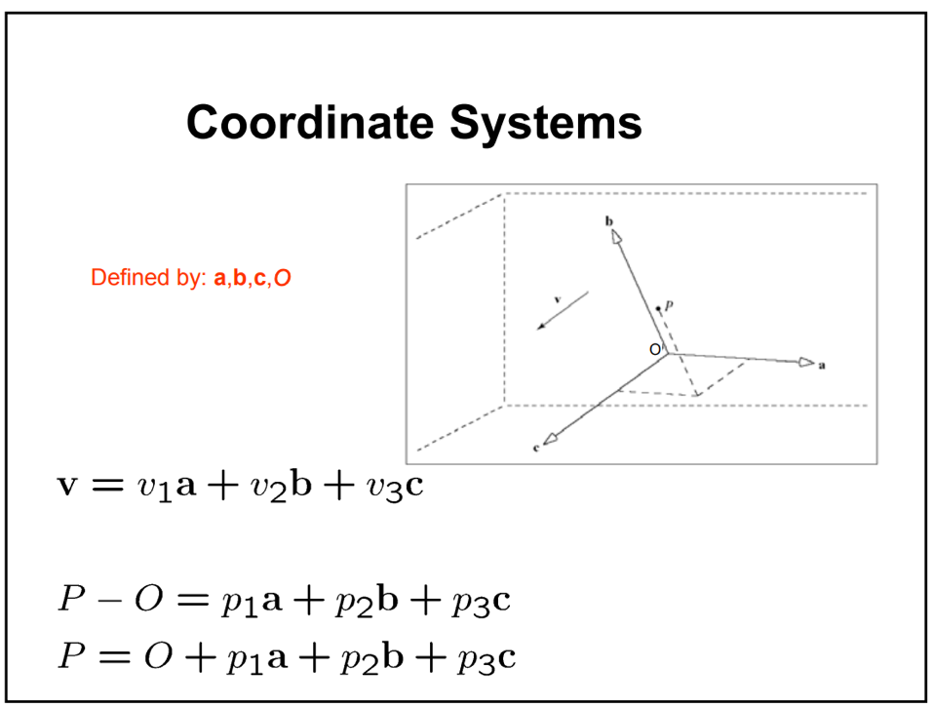
    - Review slides.
  + Given a picture be able to identify a set of OpenGL commands that turn a box (square or cube) into that picture.
    - Similar to midterm, but in an inverse way. Show pictures and tell them the transformations that go from one to the other.
* Projections
  + Given an orthographic projection, what happens to moving objects.
    - Cube in space onto the screen, the cube moves in distance forward and backward. No change to the image. But with perspective, the smaller it gets.
  + Calculate the vanishing point of a line given the equations of the line and the perspective transformation.
    - 
    - Take the limit as distance goes to infinity.
  + ?? What is the implicit formula for an edge of the camera plane in camera space?
    - Equations of bounding planes of view problem.
* Perspective projection
  + May not preserve parallel lines
  + Always preserve “in-betweenness”
  + May not preserve ratios along a line
  + Think railroad tracks.
* Rasterizing
  + Given y = ax + b how do we change the equation to be in terms of y + 1 so we can rasterize lines efficiently?
  + Given a line, which pixels will be turned on using the midpoint rasterization algorithm
    - Don’t memorize entirely, keep key ideas in mind, which is the use of the implicit form of the line to determine whether above or below, which pixel will light up,
    - incrementally step which will tell the next line which will be shown.
      * Key strategy of how it works and what will work
      * Can be applied to polynomials in general.
    - 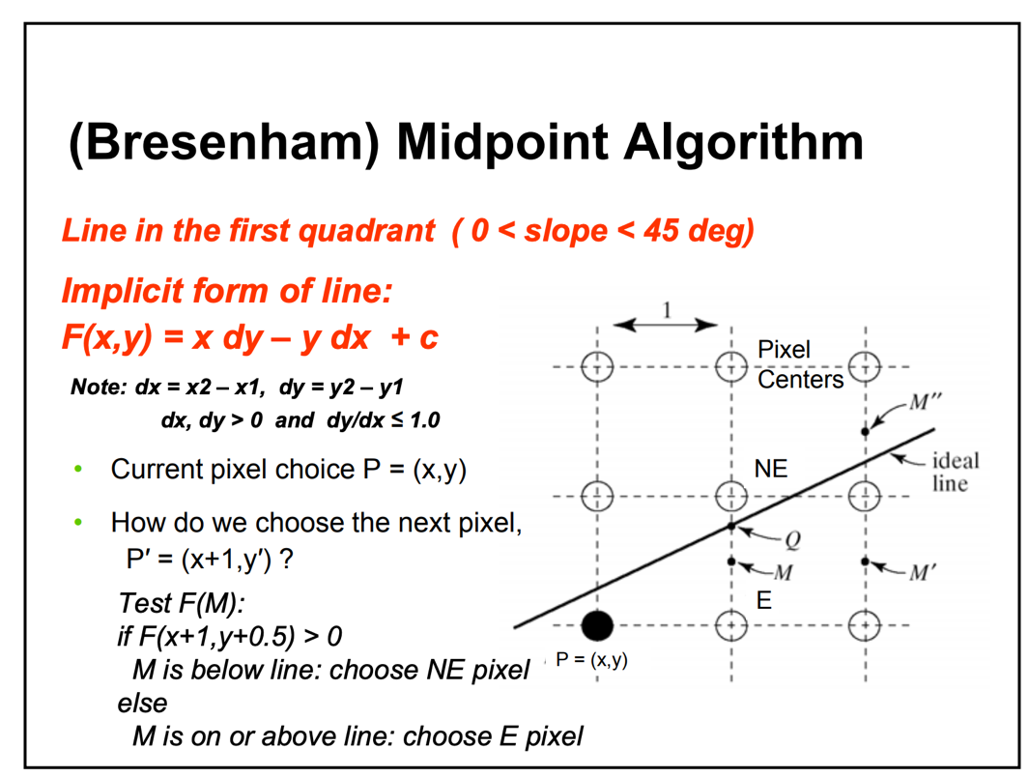
* Curves and splines
  + Given two Bezier or Hermite splines, what conditions force the combined curve to be C continuous
    - If you specify the endpoints of the curve segment and tangent vectors at the endpoints, it’s easy to get segments that share endpoints and tangents so we can make it continuous
  + Given two Bezier or Hermite splines with same endpoints how do the other control points affect them
    - Look them up online, Java examples.
    - How do control points affect the spline.
    - Other control points change the whole curve, not locally.
    - https://www.jasondavies.com/animated-bezier/
  + Given a formula for a parametric equation, calculate the implicit form of the equation.
    - Eliminate the parameter in some way, come up with the implicit form.
* Spheres and Conic sections
  + What is the parametric formula for cylinder?
    - X = 4 cos(theta)
    - Y = 4sin(theta)
    - Z = t
    - 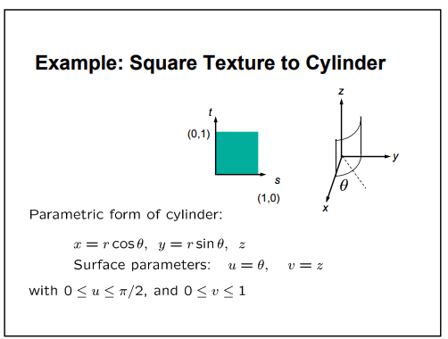
  + What is the surface of revolution for a 2D profile curve rotated along axis.
    - 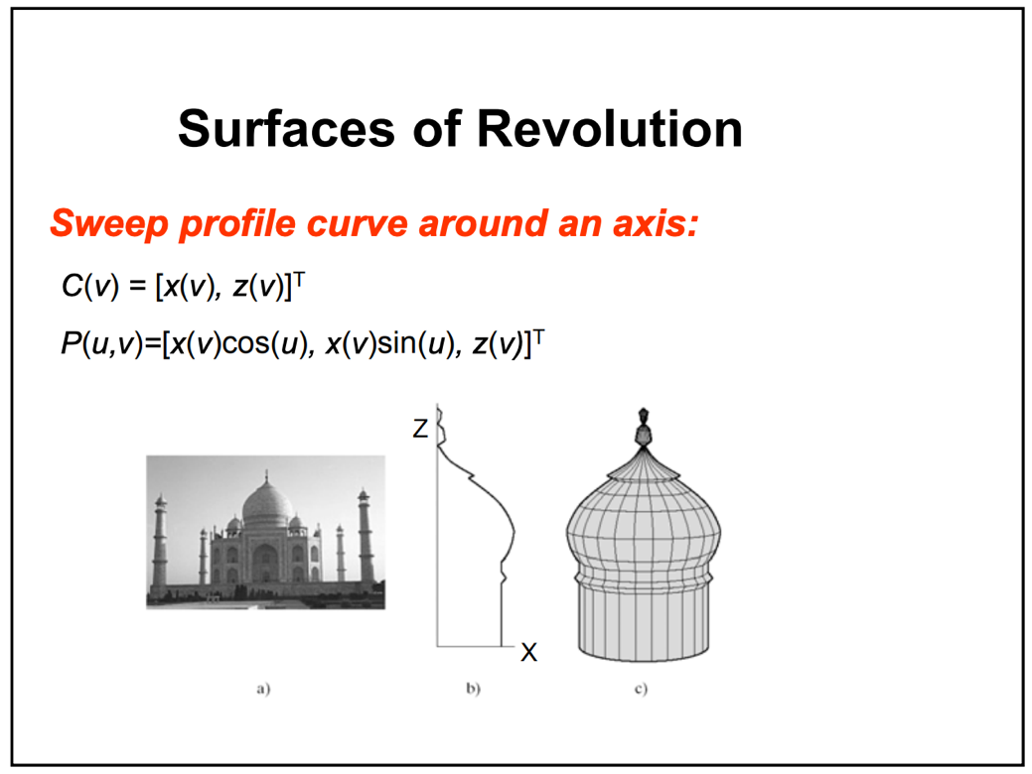
  + What does a sphere look like under perspective projection.
    - 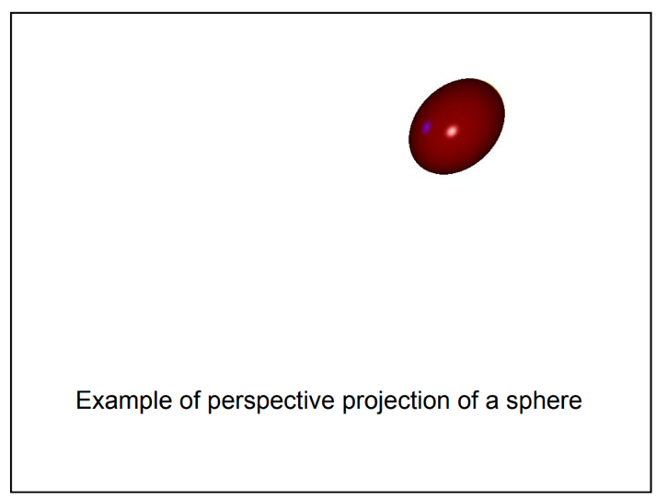
* Animation
  + Don’t memorize formulas, but understand concepts
  + Forward and inverse kinematics
    - Forward: position of end effector is a function of the state of all joints
    - Inverse: Automatically derive joint angles from end effector position
  + Dynamics (kinematics + mass and force)
    - Direct physical simulation with Newtonian motion
    - Apply relevant laws to compute accelerations, velocities, and positions as a function through time.
  + Hooke’s law (stress = elasticity \* strain)
    - Together get stress, forces that restore elastic body
  + Explicit vs Implicit Euler time integration
    - Squishy explicit
    - Hard stuff, implicit
  + Mass-Spring-Damper system (deformable solids)
    - Useful for building deformable models
    - 
  + Lennard-Jones potentials (fluids)
    - Equation for mapping the neutral repulsion of molecules.
  + Articulated body dynamics (human/animal animation)
    - Constrained multibody systems
    - Body part densities from anthropometric data
    - Masses and moments calculated from polygona model.
  + Behavior animation (human/animal animation)
    - Closely related to procedural animation
    - Common example of this approach is flocking
      * Motion of agent determined by those nearby
      * Like lion kill wildebeests